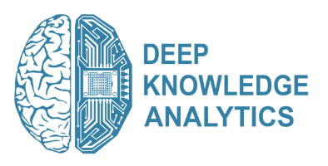

PRESS RELEASE

Surging AI Industry in the UK

Thriving industry and developing gold standards on Trusted AI put UK in company with US and China in the global AI-economy by 2020
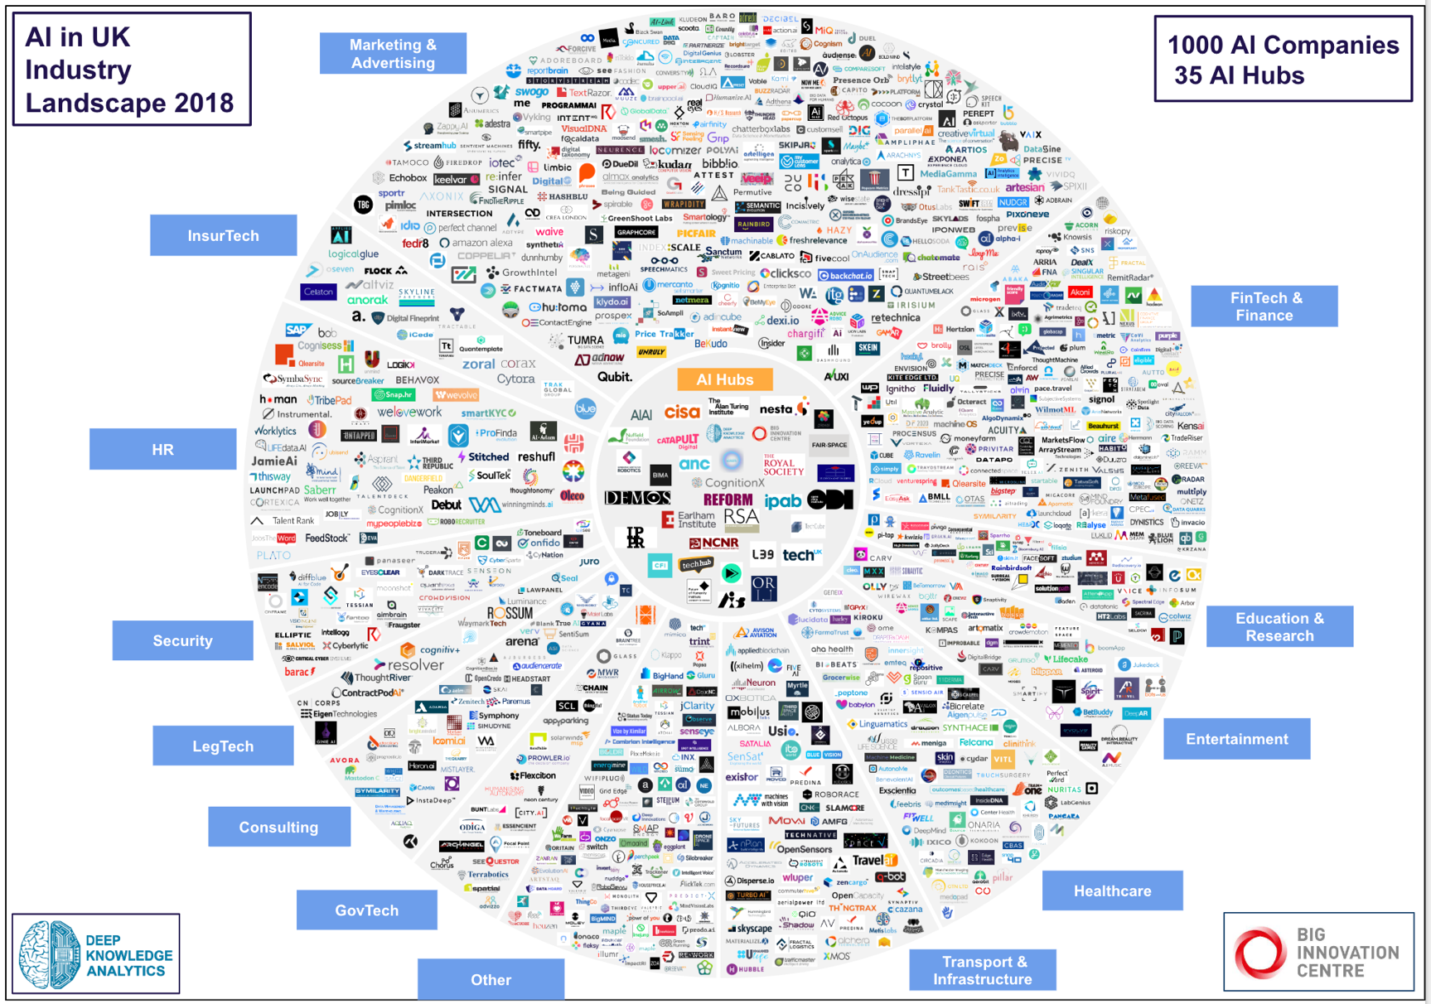

London, 24 October 2018 - A major report by Big Innovation Centre and Deep Knowledge Analytics places the UK in the third spot in the global rankings for Artificial Intelligence (AI). Launched in the House of Lords today, it foresees the UK excelling in specific subsectors and areas in the coming years.

While China is actively challenging the US as the dominant leader in the international AI race, the UK is well positioned to become an international leader in specific niches, including healthcare and fintech. The UK could also lead the way in the development of AI ethics, governance and safety frameworks on a global scale. The report identifies the substantial potential for the UK to set the gold standard for “Good Trusted AI” by thought-leading international protocols and standards for the prevention of oppression, discrimination and biases resulting from the unethical use of AI.

The 2200-page report is the largest industry analysis conducted to date; featuring individual profiles of the 1000 companies, 600 investors, 80 influencers, 35 tech hubs and research institutes, and multiple private and government entities leading the development of the UK AI-industry. Big Innovation Centre coordinated the work behind the report and acquired input from the All Party Parliamentary Group on AI, which has been a vital source of expertise on the state of AI in the UK. The contribution made by Deep Knowledge Analytics is strengthened by its specific experience conducting advanced studies of DeepTech sectors. The firm is particularly focused on the global AI market in order to assist in the comparative analysis of the UK AI-industry against the background of the international AI landscape.

AI has become much more than a technological advancement, and is now considered to be the most impactful and growing sector, affecting the future of entire nations. The UK Government has proven itself as one of the most proactive and progressive countries in its national AI-strategy, making it internationally recognised among the most pragmatic and balanced strategies. The analysis establishes several key contributing factors:
- The UK now has an AI industry of a critical scale in the global economy
- Investment in UK AI businesses has now exceeded $5bn (£3.8bn) overall and keeps accelerating
- London being a leading financial global hub
- The scientific prowess and intellectual excellence emanating from AI-savvy UK universities
- UK’s reputation for developing strong ethical traditions relating to governance and business

Professor Birgitte Andersen, CEO of Big Innovation Centre, said: “The UK now has a solid foundation to become a global AI leader, but Government must cement our unique position through investment into AI from all sectors of our economy – science, entrepreneurship, infrastructure, governance, blockchain and skills.”

Andersen added “The Chancellor of the Exchequer is announcing the Budget on the 29th of October. He should know that we are living through an economic period where success brings more success, and big is good but bigger is better.

The UK’s AI industry’s growth is now reaching astonishing pace, creating incredible opportunities within an ecosystem well positioned for international collaboration with the US and China. Not to mention working with other global growing AI hubs in Singapore, Hong Kong and the Middle East.

The UK can become a true epicentre of fair, safe and unbiased international AI-cooperation.”
Lord Clement-Jones CBE, Co-Chair of the All-Party Parliamentary Group on AI and Chair of the House of Lords Select Committee on Artificial Intelligence, said: “As shown in the report of the UK AI landscape, we have now reached the inflection point which can be reasonably described as the Cambrian Explosion of AI in the UK. Our previous reports by the Lords Select Committee on AI in the UK Parliament highlighted the nation’s very strong potential to become a global leader in AI, provided that sufficient commitments from the UK Government were made in order to prioritise it as a matter of national strategic importance from investment in industry to trust in data and algorithms.”

He added:

“There’s been a substantial surge of activities on the part of the UK throughout the past several months, ranging from the excellent work of the All-Party Parliamentary Group on AI to the establishment of the Government Office for AI. There are also well-funded Government and private sector partnerships and initiatives such as the Centre for Data Ethics and Innovation. It is clear that the UK has strongly confirmed its commitment to prioritise the further development of AI as a core part of its national agenda.”

Dmitry Kaminskiy, founder of Deep Knowledge Analytics said: “If the UK proceeds in the same direction as it was during 2017-2018, it has immense potential to become the new global leader of the 4th Industrial Revolution, the engine of economic growth and social progress. AI, Digital Economy, Blockchain, Digital Medicine, novel tech-sectors, such as RegTech, LegalTech, GovTech should be considered as being on a level playing field, with Artificial Intelligence being the main engine of innovative digital economy of the UK.

He added:

However, I would urge, UK should prioritize above others its focus on the intersection of AI with preventive medicine and Longevity”

This report is the first step in an ongoing effort to provide a framework for assessing the optimal road forward for the UK AI-industry and economy, and for leveraging tools and assets the UK can offer.
The full report and its Executive Summary will be made available from Wednesday 24th October from www.appg-ai.org and www.dka.global/ai-in-uk

ENDS
For further information, please contact
Roxy Iqbal, Communications Manager r.iqbal@biginnovationcentre.com
07772 291139 / 0203 7134036
or info@dka.global

About Big Innovation Centre:
Big Innovation Centre exists to help businesses, public agencies and universities put their open innovation principles into practice. Acting as an open innovation hub, Big Innovation Centre convenes a network of representative global companies in every sector, plus national public agencies and some of the best universities. Through this coalition we are building world-class innovation ecosystems and co-creating global innovation and investment hubs. Our aim is to help rebalance and grow national and regional economies. Our partners pool and share resources – technology, IP, data, skills, space, entrepreneurial finance – so our people can work together as co-catalysts to solve the grand challenges. Big Innovation Centre enlarges the innovative capability of its partner organisations, and itself becomes a ‘go-to’ place where commercial and public sector ideas are shared, tested and realized. We create a trusted space for people from cutting edge companies, universities and public agencies to meet and co-create a better world.

For more information visit: www.biginnovationcentre.com

About All Party Parliamentary Group on AI:
The APPG AI was formed to address the economic, social, and ethical implications of developing and implementing Artificial Intelligence. We aim to assess its impact, and, ultimately, to empower decision-makers to make policies in the sphere. Bringing together government, business, and academia we will share evidence and assist in setting an agenda for how the UK should address AI moving forward. The APPG AI is co-chaired by Stephen Metcalfe MP and Lord Clement-Jones CBE.

For more information visit: www.appg-ai.org

About Deep Knowledge Analytics:
Deep Knowledge Analytics is the analytical arm of Deep Knowledge Ventures, a VC firm focused on investments in disruptive DeepTech projects and regularly producing advanced industry analytical reports on the subjects of Artificial Intelligence, Longevity, Crypto Economy and specialising in forecasting on Convergence of Technological MegaTrends.

For more information visit: www.dka.global | E-mail: info@dka.global

